



ESTEEM NORTH ACADEMY CONSULATION ON SIGNIFICANT CHANGE
Janine Dix, Executive Headteacher, Sept 2025

HUNLOKE CENTRE
Church Street South
Chesterfield
S40 2TF
Introduction
Esteem North Academy is part of Esteem Multi-Academy Trust (EMAT). It provides education to pupils from reception to year 11 who are either permanently excluded from school or at risk of being excluded. It currently has 3 sites over the north of Derbyshire, Hasland, Barrow Hill and Chapel-en-le-Frith. It is commissioned to take pupils to roll at Day 6 of their permanent exclusion (PEX). The Local Authority has a duty to provide education at Day 6 of a PEX. DCC commission Esteem North Academy to provide these places in the north of the county. The academy therefore caters for vulnerable pupils who have no school place due to exclusion.
Due to Derbyshire having four times the number of permanent exclusions compared to other counties in the country, demand for PEX places is exceeding the number of pupil places available. Secondary schools are also requesting high quality Alternative Provision places as a preventative measure to try to prevent a PEX. Esteem North Academy would like to offer such places on a dual registered offer as a intervention to prevent a PEX. However, priority must always be for PEX pupils who have no school roll. The academy have not been able to offer more than 1 secondary dual registered place on site in the Chesterfield area due to the high demand for Day 6 PEX places.
Esteem North Academy is seeking views on a significant change proposal that will see the academy increase in pupils numbers by acquiring an additional site. This change aims to better meet the needs of PEX pupils by expanding the provision for 11-16-year-olds in Chesterfield in line with local authority demand for Day 6 places.
This change also aims to expand the dual registration offer for preventative places for pupils aged 11-16 by direct commissioning to schools.

Purpose of the Consultation
We are consulting with key stakeholders to gather feedback on the proposed changes before submitting a formal application to the Department for Education (DfE). Your views are essential in ensuring the proposal is fully informed and considers the needs of pupils, staff, parents, and the wider community. This consultation refers to the Hunloke Centre, Church Street South, Chesterfield, S40 2TF. This site is 1.1 miles from Esteem North Academy’s closest site at Hasland, S41 0LN.

Proposed Changes
- Increase in pupil capacity in Chesterfield: The academy will provide further additional places for pupils requiring a place at Day 6 of a PEX for pupils aged 11-16.
- Ability to offer dual registration preventative pupil places for pupils in years 11-16 to support all secondary schools in the Chesterfield and surrounding area.
- This change will provide an additional 100 pupil places.
- Provision of vocational qualifications – to provide a further enhanced bespoke educational offer to the pupils on roll at Esteem North academy rather than out sourcing of this.
- Provision of vocational qualifications – offer of places to mainstream schools via a service level agreement. There is a need for this by secondary schools in order to meet pupil need and provide bespoke offers.
- Additional staffing and resources: recruitment of additional teaching and support staff for the vocational offer which will be developed over a period of time.
Rationale for the Change
- Demand for pupil places in the academy has risen significantly since 2022. The academy is creative with bespoke timetables and pathways to meet as many pupil’s needs as possible. Each of the 3 Esteem North sites have been developed over the past few years to increase pupil capacity as far as possible. However, demand is greater than the current secondary space in Chesterfield can provide due to the continued number of pupils that are subject to a permanent exclusion in this area. The Hasland site has been to capacity since December 2023.
- Last year Esteem North academy took to roll approximately an additional 60 pupils in Chesterfield aged 11-16. This provided these pupils with a school roll and a blended educational offer where pupils were safeguarded by professionals. These pupils have been provided with bespoke timetables. All of which have some time over their week on site at the Hasland base. However, there is no space to have these additional pupils in school on site on a full time basis. Their timetables may include on site learning, online learning, home tutoring on a one to one basis, work experience, or off site commissioned vocational alternative provision.
- From January 2025 onwards, the academy offer was full to capacity in the Chesterfield area and it was not able to take any more pupils in years 7 to 11 in the Chesterfield area to roll. This created a waiting list for academy places. The Local Authority remain responsible for the education of these PEX pupils.
- There are currently 13 pupils without a school place and on the waiting list already at the start of the academic year as the Hasland site is full to capacity. We predict that there may be a further 50 pupils excluded over the year. These pupils will not have a school place.
- The Hasland site has accommodated additional pupils since January 2024 for part of the day to ensure that the pupils had access to a school site. However, this has affected the pathway 5 offer for the Hasland pupils. Pathway 5 offers vulnerable pupils with additional needs more space on site and allows for small group or one to one learning. The additional pupil numbers have made pathway 5 a challenge to offer due to more pupils accessing the site.
- This additional site should be able to allow Esteem North Academy to take all PEX pupils to roll in the north of the county at Day 6. Therefore, all PEX pupils should have a school place as long as trends remain as they have over previous years.
- This will therefore, allow the pupils to have the same core educational offer as the other secondary age pupils on roll at Esteem North Academy as there will be physical space for them.
- Based on historical PEX trend data, we predict that Esteem North academy will be required to offer, in total over the sites, circa 350 pupil places for Day 6 pupils. The 3 sites currently provide 255 places.
- There is a growing demand for AP places from local authorities, and schools requiring specialist intervention for pupils who would benefit from small-group, targeted education as a preventative measure to prevent a PEX. To further address this and broaden our impact, the site will actively pursue direct commissioning opportunities with local schools and neighbouring local authorities, extending our reach beyond Derbyshire County Council through dual registration places.
- Exclusion rates are above average in Derbyshire and this provision will be a preventative measure.
- This larger additional site and change in pupil places will allow for the curriculum to be expanded with vocational qualifications. This will broaden the academy’s offer for the pupils on roll, but also offer opportunity for schools to commission Esteem North via a service level agreement. This will benefit mainstream pupils by providing further preventative places in our academy.
- The additional space and wider vocational offer will allow more pupils at one time to be timetabled to attend site.

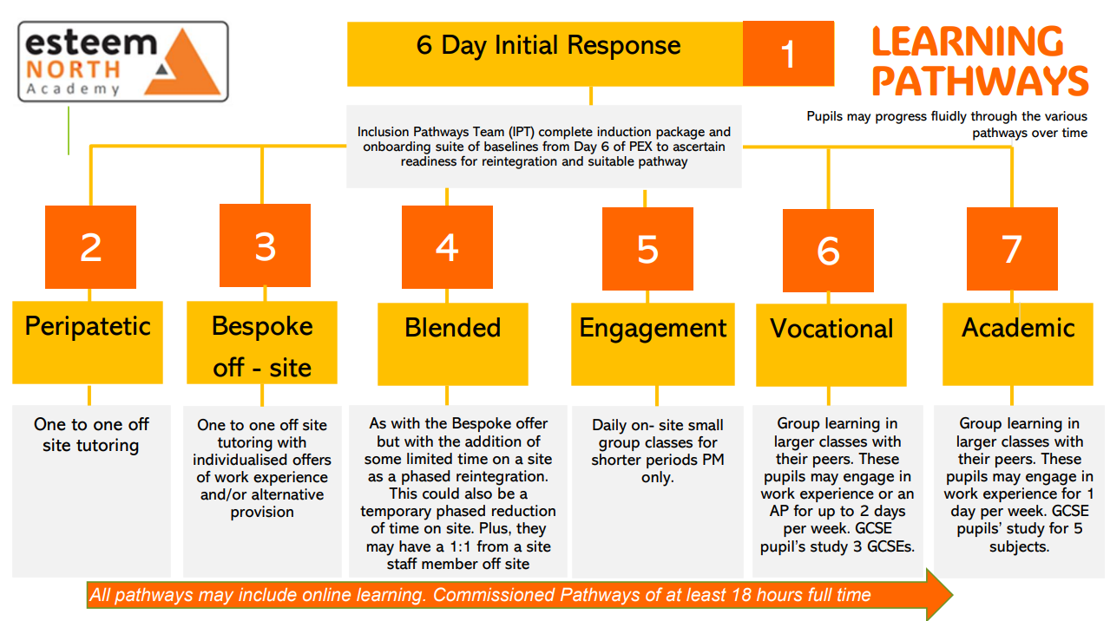

Potential Impacts and Mitigations
Educational Impact
- PEX pupils will be provided with an on- site curriculum offer where they can achieve GCSEs and Functional skills.
- All PEX pupils will be offered a school place at day 6 so that they can engage in education with their peers.
- All PEX pupils will achieve outcomes which will have a positive impact on post 16 options and their future careers.
- All PEX pupils will be on a school roll and have full support from a level 6 careers advisor and pastoral team who provide wrap around holistic support including safeguarding.
- All PEX pupils will be on a school roll and have a place in a physical building rather than being at home which may affect parents ability to work. More pupils will be supervised and safeguarded in school.
- Pathway 5 pupils at Hasland will have more space to learn and be provided with one to one learning where this meet their needs.
- This larger site at Hunloke will allow for Esteem North to offer all pathways for all of its secondary age pupils regardless of which site they are on roll at. This will positively impact pupils by meeting need as there will be more flexible learning spaces tailored to pupils needs.
- Increased curriculum options for more pupils. Vocational offer suggested to include: hospitality & catering, woodwork/joinery/enterprise, public services, sport, hair & beauty, childcare, health & social care, photography and Duke of Edinburgh.
- Potential for a nurture provision for secondary age vulnerable SEND pupils based on a primary model with a life skills curriculum in a safe space.

Staffing and Workforce
- There is some final recruitment required to ensure this new site is staffed to offer the same educational package as the other secondary sites including a literacy intervention assistant, administrative assistant, teachers and teaching assistants.
- An increase in pupil numbers will require an increase in size of the safeguarding team. This is already in process.
- Much of this recruitment is currently already in place as the academy has been educating additional pupils with lack of physical space since January 2024.

Operational and Logistical Considerations
- Consideration has already been made to allow for a revised Senior Leader structure to ensure the new site has high quality leadership and oversight.
- We have recruited to a leadership position to manage this site operationally.

Transport and Accessibility
- Engagement with the Local Authority regarding any necessary transport adjustments. Pupils who reside over 3 miles from our school site are entitled to transport provided by the Local Authority. This may be via taxi or bus pass. Most pupils share a taxi or a small mini bus into school.
- Clear travel and access arrangements for pupils and families
- Communication with surrounding stakeholders around the impact of increased transport during academy start and finish time.

Approval needed from the Department for Education
When an Academy Trust proposes changes to a school's characteristics, as outlined above, the Department for Education requires specific criteria to be met, including a formal consultation process. This process must be completed before any changes can be implemented, in accordance with the Academies Act 2010. The publication of this document marks the beginning of the consultation process led by the Esteem Multi Academy Trust, ensuring that all stakeholders can share their views on the proposal. The guidelines for the process are set out in Making significant changes to an Open Academy.
Making significant changes to an academy

The Consultation
This marks the beginning of the consultation process, offering stakeholders an opportunity to share their views on the proposal.
The consultation process will follow these steps:
1. Launch of Consultation
a. This full consultation will be live on Friday 19th September 2025 from 12pm and a notice of consultation will be published on the Esteem Multi-Academy Trust website. https://www.esteemmat.co.uk/
2. Consultation Period
a. The consultation period will run for five weeks, closing 12pm Friday 24th October 2025.
b. During this time, stakeholders are invited to review the proposal and submit their feedback.
c. The rationale for this consultation and further details can be discussed via a public forum which will be held on Monday 6th October 2025. The start time for this meeting is 4.45pm. The forum will close for questions at 6.15pm. This will be held at Spire Nursery and Infants School on the same site as the Hunloke Centre itself. Derby Road, Chesterfield, S40 2EU.
3. Review Feedback
a. At the end of the consultation period, the Trust will review and consider all submitted comments.
4. Submission to the Regional Schools Commissioner
a. Once all feedback has been considered, the Trust will submit the proposal, along with the consultation responses, to the Regional Schools Commissioner as part of the significant change process.

Stakeholder Engagement
We invite views from:
- Current pupils
- Parents and carers of pupils attending Esteem North Academy
- Staff
- Governors
- Esteem Trustees
- Local authorities
- Commissioning partners
- Neighbouring schools and community groups
- Community safety team
- NHS
- CAMHS
- Integrated Care board (ICB)
- Police
- DfE
- Local councillors
- MP
- Unions
- Derbyshire Transport Team
- Local Authority Admissions Team
- Local Authority Inclusion Team
- Local residents surrounding the Hunloke Centre
- Schools surrounding the Hunloke Centre
- Local business’s surrounding the Hunloke Centre
- Parents of children in the area of the Hunloke Centre

How to Share Your Views
- You can provide feedback in the following ways:
- Complete our online survey by clicking on the link below
https://forms.office.com/e/Z5uVL5uQaC

- Submit written feedback via email: janine.dix@esteemnorthacademy.co.uk
- Or via using the QR code below.



Next Steps
- Consultation opens: 19th September 2025
- Consultation closes: 24th October 2025
- Review of responses: 27th October 2025
- Submission of application to DfE (Fast Track): 3rd November 2025
- Implementation of approved changes: 8th December 2025
We appreciate your time and engagement in this important consultation process. Your feedback will help shape the future of Esteem North Academy and ensure we continue to provide high-quality education and support for our pupils.

